**Microfinance Bank loan Analysis:**

Microfinance institutions (MFIs) play a critical role in promoting financial inclusion by providing small loans to underserved populations. However, due to limited borrower credit history and informal income sources, MFIs often face challenges in loan recovery and risk management. This project focuses on the analysis of a microfinance loan dataset to extract meaningful insights to support better decision-making. The key objectives include: Analyzing borrower demographics and loan characteristics. Identifying patterns and factors influencing loan repayment and default. Exploring regional or group-based trends in loan performance. Building predictive models (if applicable) to assess default risk. Recommending strategies to enhance loan targeting and reduce defaults. The insights gained from this analysis will help microfinance institutions improve loan allocation, minimize risk, and maximize both financial sustainability and social impact.

**Objectives:**

To analyze borrower demographics such as age, gender, location, and occupation to understand the target population served by microfinance.

To study loan characteristics including loan amount, repayment terms, and loan purpose to identify common trends and preferences.

To evaluate repayment behavior and identify factors associated with loan default or successful repayment.

To detect patterns and trends across different borrower groups, regions, or loan types.

To develop predictive models (if applicable) to estimate the risk of loan default based on historical data.

To provide actionable insights and recommendations that can help microfinance institutions optimize their lending strategies and reduce financial risk.

**Research Questions;**

To guide my analysis, the research is structured around the following key questions:

1. What is the distribution of loans across different loan types?

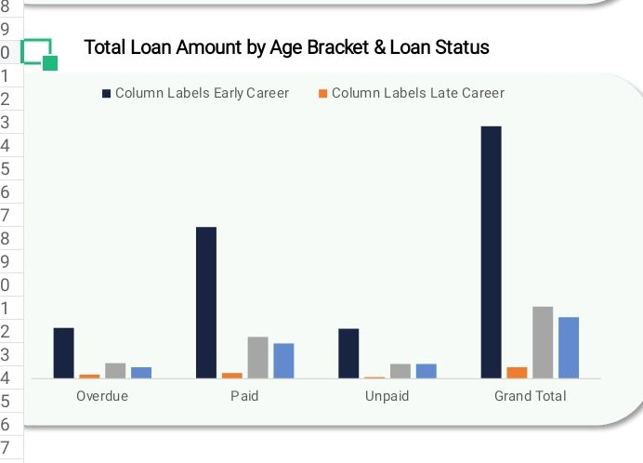2. Which demographics (e.g., age, gender, region) have the best repayment rates?

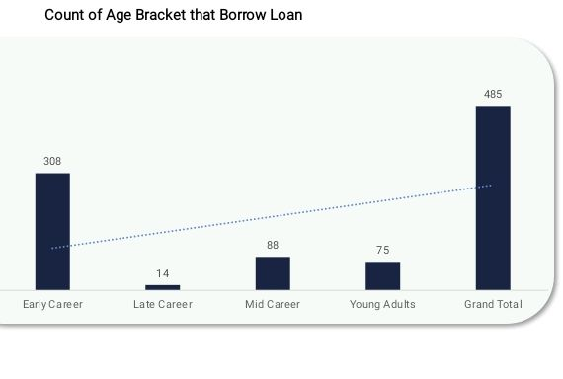

3. What is the proportion of loan borrowed by each age bracket?

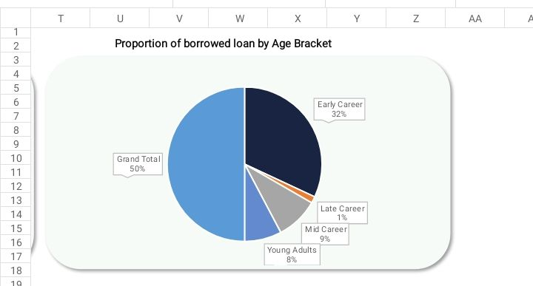4. How do loans and repayments vary across Education status?

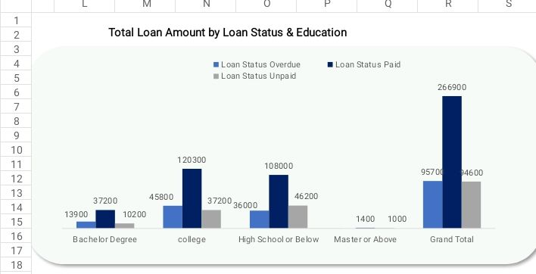

5. What is the impact of loan duration on repayment performance?

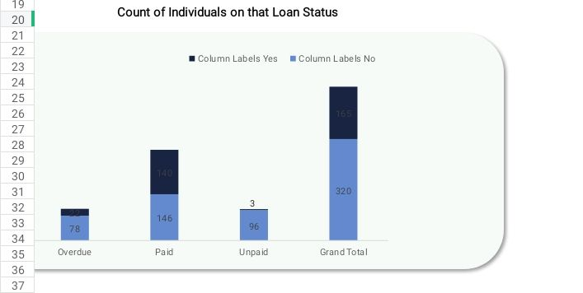

**DATA COLLECTION**

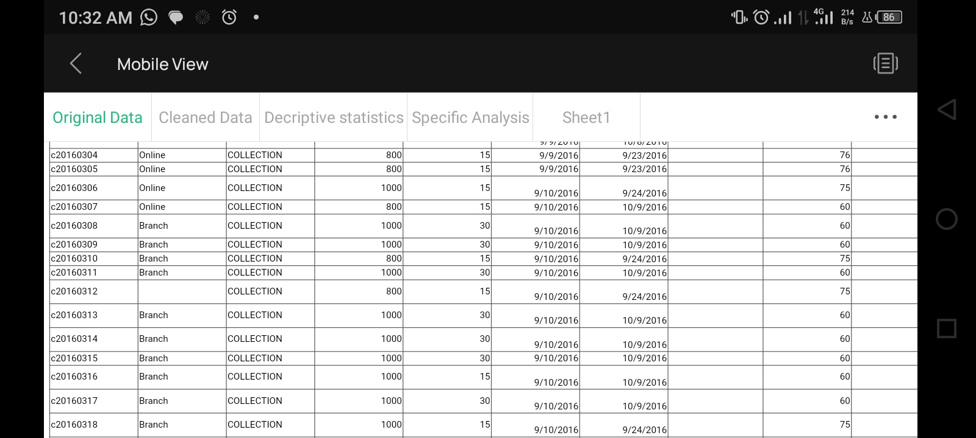

**Data Cleaning**

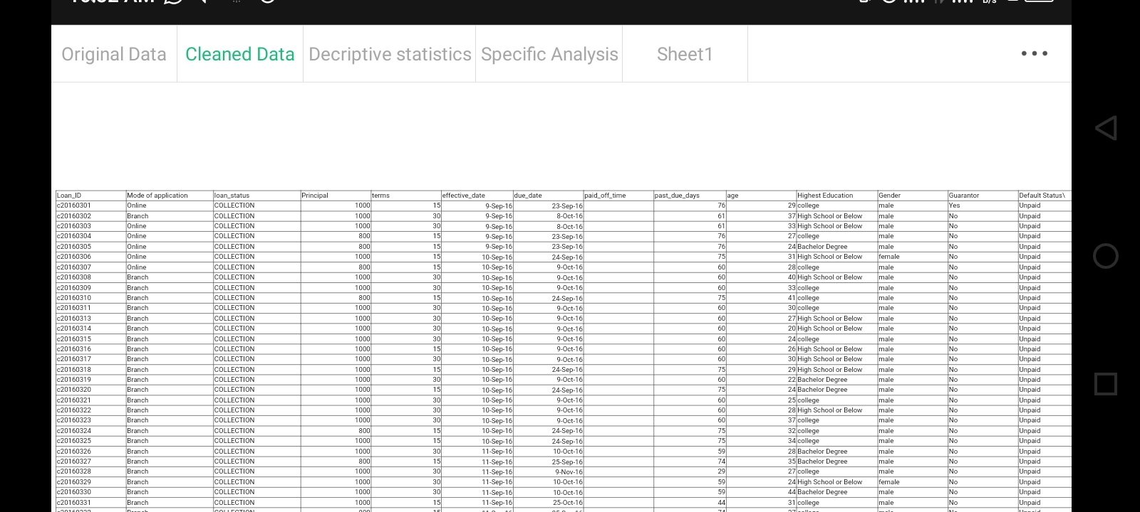

The dataset consists of borrower demographic attributes, loan records, and repayment information. Initial assessment revealed the presence of inconsistencies, missing values, and unstandardized labels.

**Cleaning Steps Taken**

1. **Formatting & Table Structure:** Data was formatted into a structured table using Excel’s “Format as Table” feature for consistency and filtering ease.
2. **Handling Missing Values:**
   * A missing age value was replaced with the median to maintain data integrity.
   * Other missing entries were reviewed and filled appropriately.
3. **Dealing with Duplicates**: Duplicate rows were checked and eliminated using borrower ID and demographic indicators
4. **Standardizing Loan & Demographic Categories:**

Loan Collection Status was recoded into:

• Paid: Paid before due date

• Overdue: Paid after due date

• Unpaid: Not paid by due date

The age was standardized into age brackets:

* 18-25 → Young Adults
* 26-35 → Early Career
* 36-45 → Mid Career
* 46-51 → Late Career
* 51+ → Retired

**DATA PROCESSING**

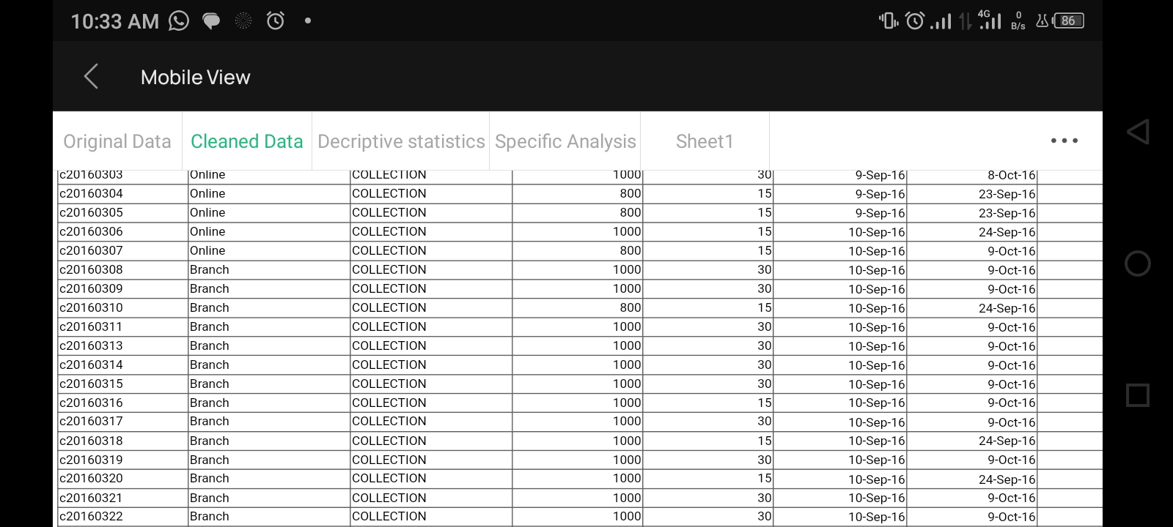

**To structure the dataset for better Analysis, several actions were taken**

Transformed "Loan Collection Status" to

* Collection = "Unpaid"
* Collection_Paidoff = "Overdue"
* Paid_off = "Paid"

**Default Status**

"Unpaid" Loan wasn't paid before the due_date

"Overdue" Loan was paid exceeding the due date

"Paid" Loan was paid before the due date

**DASHBOARD**

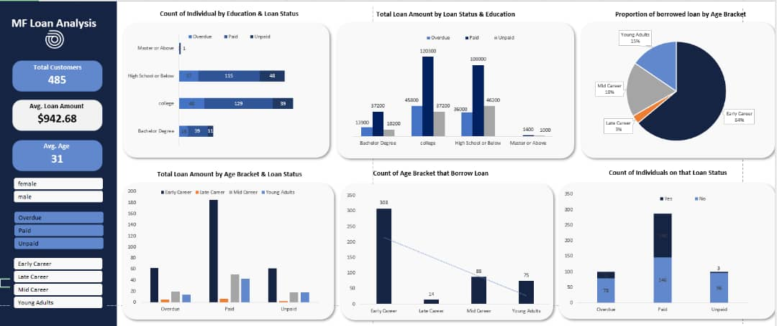

The pivot tables were used to draw charts that were well structured on a new worksheet composing the dashboard.Here is the breakdown of the chart.

The dataset comprises a total of 485 loan customers, with an average borrower age of 31 years. The average loan amount disbursed was approximately $942.68. This suggests that the bank primarily serves a youthful population with modest loan sizes—characteristic of microfinance lending aimed at income-generating activities or small business support

1. **Count of Individuals by Education & Loan Status**

I High School or Below has the most borrowers, with many loans marked Paid (115) and Unpaid (40).

Ii College follows closely, with 129 Paid loans and 38 Unpaid.

III Bachelor Degree holders have fewer loans, mostly Paid.

IV Very few individuals have a Master’s degree or above.

1. **Total Loan Amount by Loan Status & Education**

When loan amounts were examined, College-level borrowers stood out with the highest total repayment figures, reaching nearly $130,000 in fully paid loans. High School-level borrowers followed closely with around $100,000 in successful repayments. However, both groups also showed the highest volume of overdue and unpaid loans, which highlights the importance of nuanced borrower profiling rather than relying solely on education level as a predictor of repayment behavior

1. **Proportion of Borrowed Loan by Age Bracket (Pie Chart)**

Borrowers were categorized into four age brackets: Early Career, Mid Career, Young Adults, and Late Career. The Early Career group (typically in their 20s) emerged as the most active borrowing segment, accounting for over half (54%) of the total borrowed loans. This group also had the highest number of individual borrowers—308 out of 485. This indicates that young, aspiring individuals form the backbone of the microfinance clientele, likely due to their entrepreneurial drive and limited access to traditional banking.

The Mid Career and Young Adult brackets had moderate borrowing activity, with steady repayment patterns. The Late Career group (older borrowers) had the least borrowing activity, both in terms of loan counts and volumes, possibly due to reduced financial needs or risk aversion

1. **Total Loan Amount by Age Bracket & Loan Status**

When loan statuses were compared across these age brackets, Early Career borrowers once again stood out—not only for borrowing the most but also for maintaining a relatively healthy repayment record. While some defaults were observed, a majority of their loans were successfully repaid. Other age groups followed similar trends, though with fewer loan accounts.

1. **Count of Age Bracket that Borrow Loan**

Early Career again leads with 308 borrower.

Other brackets have significantly fewer:

Mid Career: 88

Young Adults: 75

Late Career: 14

1. **Count of Individuals on that Loan Status**

Majority of borrowers are in Paid status.

Fewer loans are Overdue or Unpaid.

Across the entire borrower base, the majority of loans were marked as “Paid,” indicating a favorable overall repayment trend. Fewer borrowers fell into the “Overdue” or “Unpaid” categories, suggesting that most customers understand and adhere to repayment expectations. Nonetheless, the presence of unpaid and overdue loans—especially among certain education levels—points to areas where borrower support, monitoring, and intervention could be improved.

**Key Insights**

1. Younger, Early Career borrowers form the bulk of the customer base and loan volume.
2. College-educated individuals display high repayment performance, making them a favorable target group.
3. Borrowers with High School or lower education present higher default risk.
4. Master’s degree holders, though few, show strong repayment behavior.
5. The overall repayment trend is positive, with most loans being repaid on or before the due date.

**Recommendations**

* Prioritize Early Career and College-educated borrowers for future lending.
* Introduce credit education for high-risk groups (e.g., High School-level borrowers).
* Implement predictive modeling tools to flag high-risk loans in advance.
* Offer incentives for on-time repayments to reinforce positive borrower behavior.
* Explore region-specific strategies if regional data supports variation in loan performance